

**Model Driven Software Engineering**

**COEN-6312**

Instructor: Dr. Wahab Hamou-Lhadj

**University Management System**

**Deliverable 4 (State Machines)**

**Team: Hungry for Troubles**

|  |  |
| --- | --- |
| Hem Raj Regmi | 40015416 |
| Bitta Rani Rana | 40031066 |
| Aeisha Vyas | 40043598 |
| Manjot Kaur Grewal | 40014336 |
| Harmanpreet Kaur Rajput | 40014345 |

**Table of Content**

Table of Contents

1. State Diagram, Description and Action Specifications

* Book Class 3
* Course Registration and Exam Class 4
* Database Class 5
* Payment and Financial Institute Class 6

1. Contribution Table 8

**1. State Diagram, Description and Action Specification**

1. **Book Class**

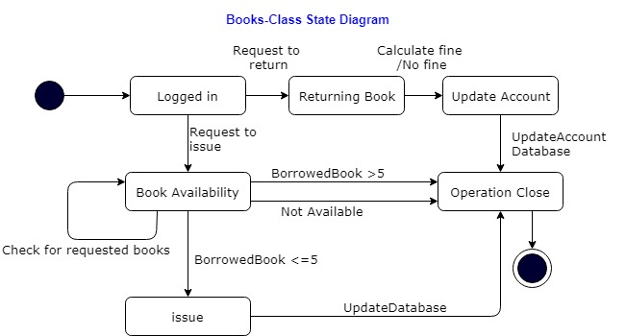

**Description:**

It represents the flow that a user will take to borrow a book. When the user requests to get a book issued, then book availability is checked. If the book is not available, then the operation is closed. Also, if the user wants to return the book, the system calculated any overdue. The account of the user is updated, and operation is closed. Here the database is updated side by side.

**Operations and Action Specifications:**

|  |  |
| --- | --- |
| Operation | Action Specification |
| Calculate Fine | The number of overdue days is calculated and multiplied by the fine per day. |
| Borrow books (more than limit) | The message will have displayed to indicate that limit has been reached. |
| Book Issued | Receipt is generated indicating the date of issue and date of return along with book code. |

1. **Course Registration and Exam Class**

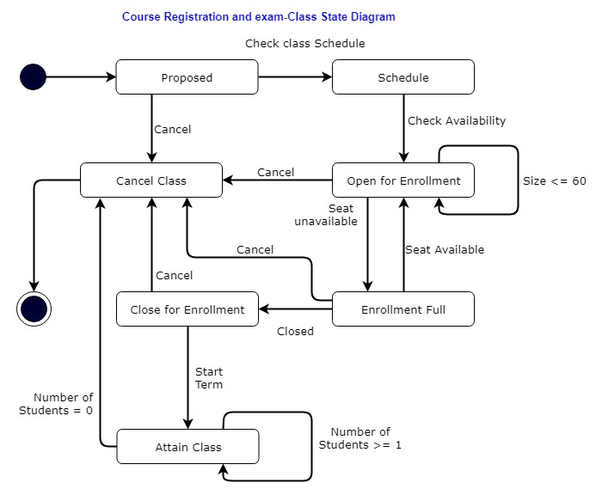

**Description:**

This state diagram represents that when the proposed courses and their respective schedules are out, students can enroll for the same. After the course enrolment process the class begins. Also, there are certain conditions applied on some of the states.

**Operation and Action Specifications:**

|  |  |
| --- | --- |
| Operation | Action Specification |
| Check class schedule | Student can check the schedule of the course offered |
| Check Availability | Availability of the course is checked. The course is not available in case the number of the students enrolled exceeds 60 or if no one enrolls |
| Seat Available | Student can enroll |
| Seat unavailable | Student cannot enroll |

1. **Database Class**

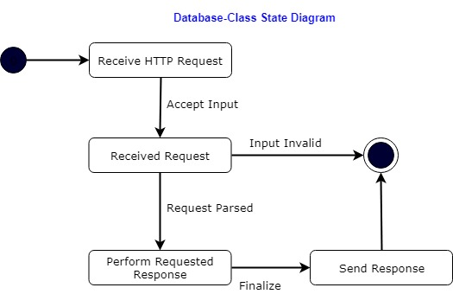

**Description:**

The database receives the HTTP request, the request is parsed, and the desired action is performed for the requested response until the operation is completed; and the final result is stored in the system.

**Operation and Action Specifications:**

|  |  |
| --- | --- |
| Operation | Action Specification |
| Request Parsed | The Database is updated |
| Input is Accepted | The input is analyzed to check for validity |

1. **Payment and Financial Institute Class**

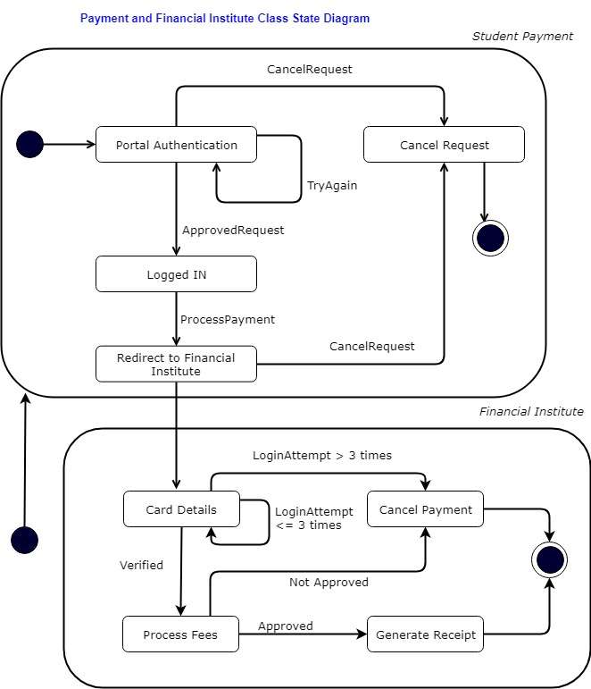

**Description:**

The student logs in to the university website using the username and the password. If the request Is approved, then the student selects the payment link under the finance account. That redirects to the financial website where the student chooses the payment mode (visa, debit) and enters the card details and submits the payment. If the payment is processed a receipt is generated.

**Operation and Action Specifications:**

|  |  |
| --- | --- |
| Operation | Action Specification |
| CancelRequest | The request is cancelled when user is not authenticated or when exceptional transmission error occurs |
| ApprovedRequest | The user is authenticated |
| ProcessPayment | Payment process is commenced which directs the user to the financial website |
| LoginAttempt | The card details are asked, and maximum three attempts are allowed |
| Verified | Student pays fee successfully |
| Approved | Receipt is generated |
| Not Approved | Exceptional Transmission error |

**4. Contribution Table**

|  |  |  |  |
| --- | --- | --- | --- |
|  | **State Diagram** | **Brief Description** | **Operation and Specification** |
| Hem Raj Regmi | √ | Report Preparation | Payment, Enrollment |
| Bitta Rani Rana | √ | Payment, Database | Payment, Enrollment |
| Aeisha Vyas | √ | Books, Enrollment | Payment, Enrollment |
| Manjot Kaur Grewal | √ | Books, Database, Payment | Books, Database |
| Harmanpreet Kaur Rajput | √ | Books, Database, Payment | Books, Database |

**GitHub:** <https://github.com/sangamsyabil/COEN6312---College-Management-System>